HAPPY HALLOWEEN
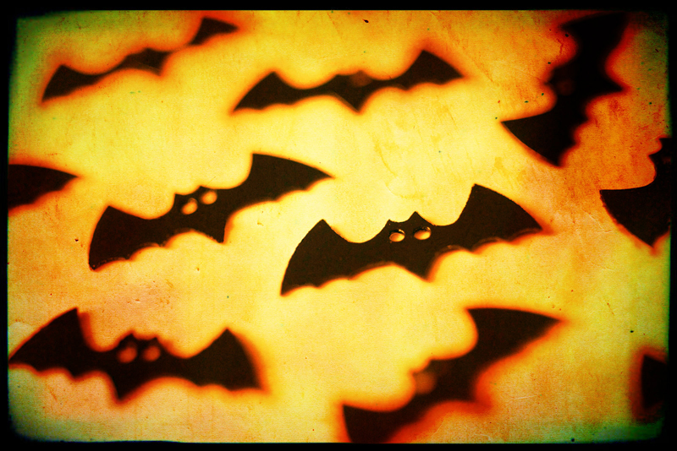

HALLOWEEN STORY
STRANGE NIGHT

Each group of text is in a text box. Whoever screams or lets go of an item looses. The person at the head of the table passes it to the left and right. woolly rabbits feet, slippery skinned grapes, anything cold or with texture will feel unusual to the unseen eye.

Halloween is a strange night when things fall out of the sky. The witches hover about and things are so bably mixed up the next day from all the candy. And there might be some toilet paper in people's trees. You can see children discussing plans for their escapades and setting the town awry. With the grinning Jack o' Lanterns head bright stay inside where it is safe! Let the frigth and jokes go on outside.
Bat image: www.freeimages.co.uk
Free Template by: www.worddraw.com
This happy halloween template can be customized and used for event flyers, invitations or family newsletter. You can add your own text by replacing the placeholder text included in the file. The fonts used in this template are Bookman Old Style for the article text, Sybil Green for the Article Titles, and Impact for the title "Happy Halloween"

Begin placeholder text: Halloween and fear seem to go together; then this is a scary game to play while still seated around the halloween dinner table with dark candle light at night. There will be a witch and a dark tablecloth and it is called the shiverings. All hands under the table and creepy things pass between the players without seeing what they are. The gooey the boney the furry, the living and the dead.

