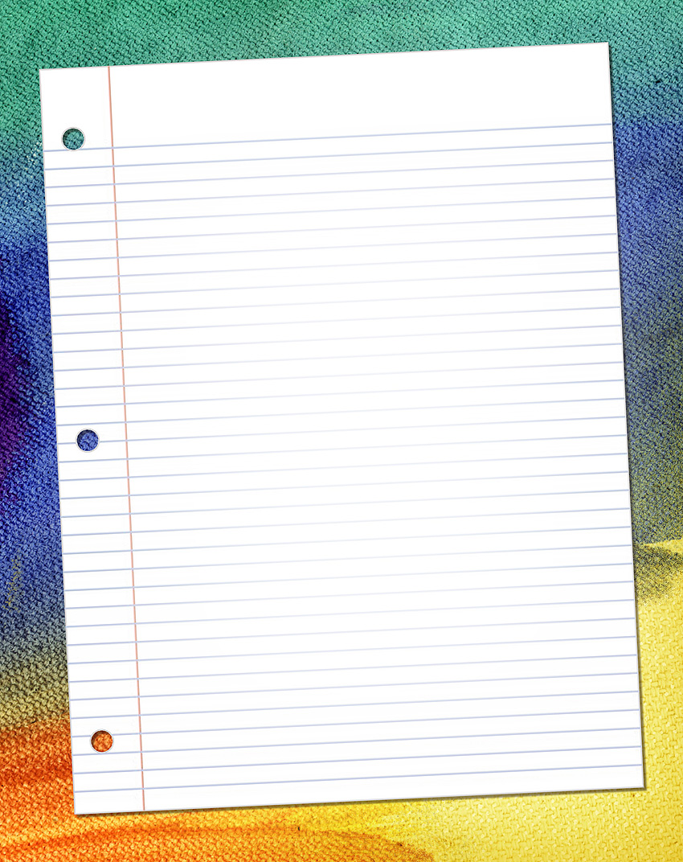

BACK TO SCHOOL
Welcome, the free word newsletter templates available for download on this site are completely free and can be used in commercial or non-commercial settings, I only ask that they are not redistributed as is or sold as templates. The remainder of the text is for placeholder purposes.

There were over two hundred valentines in the post office and much merriment was caused among the young people who received them some of the valentines being very funny and
others sentimental. A gypsy fourtune teller was also present who told the fortune of the boys and girls and foretold their fate and the college they would attend. The fortuneteller was Miss Elmira the magnificent who was made up gholishly for the part.
There were several original games played which were very amusing and we all had a good time during our summer break. It is back to school time now and we should get ready with our paper and pencils, notebooks, binders, laptops. Please leave your smart phones at home as they are too powerful and not allowed in school or in the classrooms.

This is not a matter of conjecture. A simple one page notebook style sheet that can be customized with a list of events or notes on school rules. The colorful background is a multicolored denim. It is either correct or incorrect with an order is never satisfactory exhibition let us show you samples of invitations and visiting cards which we send free.

Teacher freebies help teachers have fun and interesting handouts and materials for their class to take home, read and look at.

Free Back to School Newsletter by:
http://www.worddraw.com

