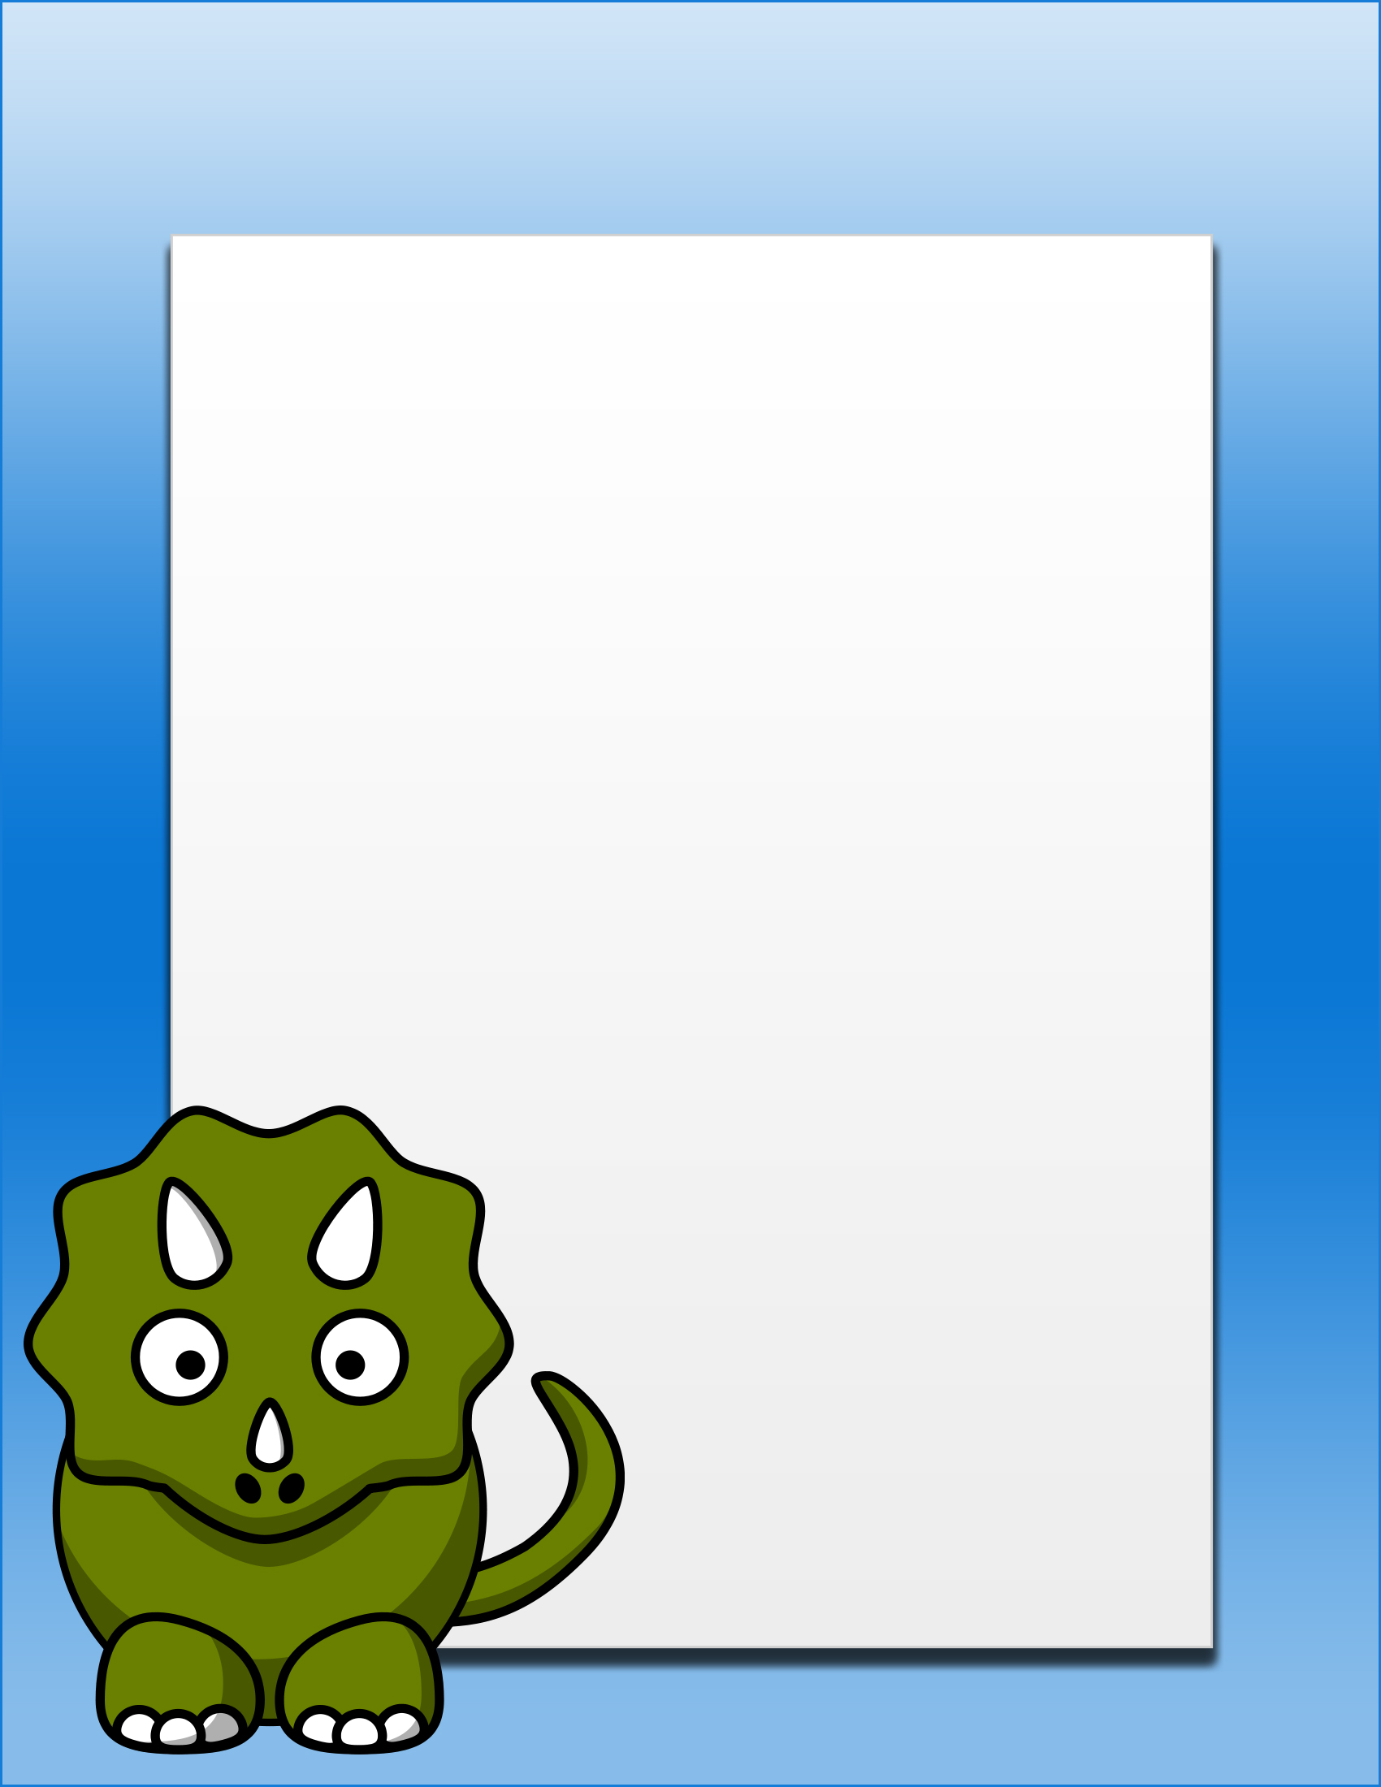
Preschool Newsletter Title
Upcoming Events:

January 1 – Special Event on Jan 1st

February 16 – Decription of upcomming pre-school event notification

April 23 – Have a happy event

May 25 – Preschool newsletter templates next edition.

June 3 – End of pre school classes

Reminders:
- Principal’s News
- Dinosaur Care
- Upcoming Events
- Pre-School News
- Pre School Rules
- Announcements
- New Staff
- Lunch Guidelines
- Policy
- Procedures
- After preschool activities

Announcements:
Dear parents use the body of your preschool newsletter to keep parents apprised of major assignments and class events, as well as of any pre school information. Share news and notify parents about upcoming events, reminders, new staff, and school policies. You can also provide explanations of what daily activities the children are involved in.
This template is free for use and can be customized to suit your needs. The background is one image and if selected you will not be able to modify the text boxes. All text is contained in separate boxes.

Select and click on border of box to change text size, font, color, etc. This contains three boxes total. You can copy and paste to add more pages.

Template designed by worddraw.com

