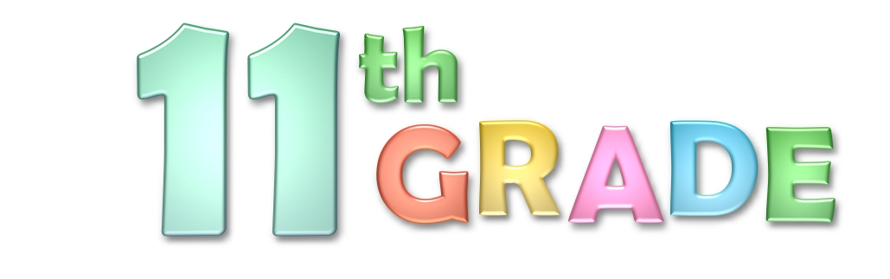

TEACHER’S ELEVENTH GRADE CLASS

VOCABULARY:

periodical
publication
newspaper
events
informative
articles
features
editorial
publishing
writers
classroom
words

NOTES FROM TEACHER:

Insert a personal message.

SUBJECTS:

Write classroom subjects to be covered.

CALENDAR:

List
Date
Event

Free 11th Grade Newsletter Template for teachers created and designed by worddraw.com

